Abdull Haseeb
SU92-BSAIM-F24-050
BSAI-3A
AI LAB NO 1
🧾 Documentation for ToDoList Class
Overview
The ToDoList class is a simple command-line To-Do List manager built in Python.
It allows a user to:
- Add tasks
- View all tasks
- Mark tasks as completed
- Delete tasks
- Exit the program
It uses loops, recursion, user input, and list operations to handle the to-do list.

Class Structure
Class Name: ToDoList
Attributes:
- self.task_list:
A Python list that stores all the tasks entered by the user.
Libraries Used:
- time — used for short pauses (via time.sleep()) to give a better user experience.

Methods Description
🧩 1. __init__(self)
Purpose:
Initializes an empty list task_list to store tasks.
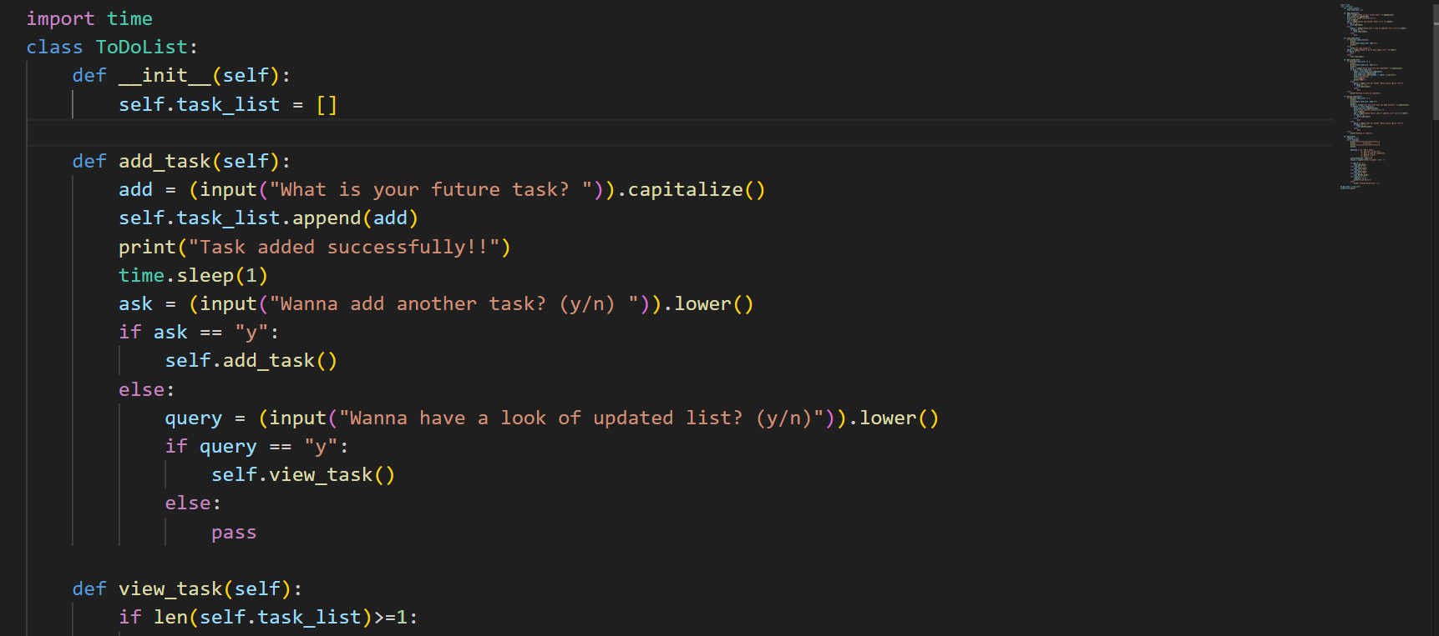
Functionality:
self.task_list = []
When a new object of ToDoList is created, this constructor runs automatically and sets up the task list.

📝 2. add_task(self)
Purpose:
Allows the user to add one or multiple new tasks to the list.
Steps:
- Prompts the user to input a task.
- Capitalizes it and appends to task_list.
- Asks if the user wants to add another task.
  - If yes, calls itself recursively.
  - If no, offers to display the updated list.
- Displays a confirmation message after successful addition.
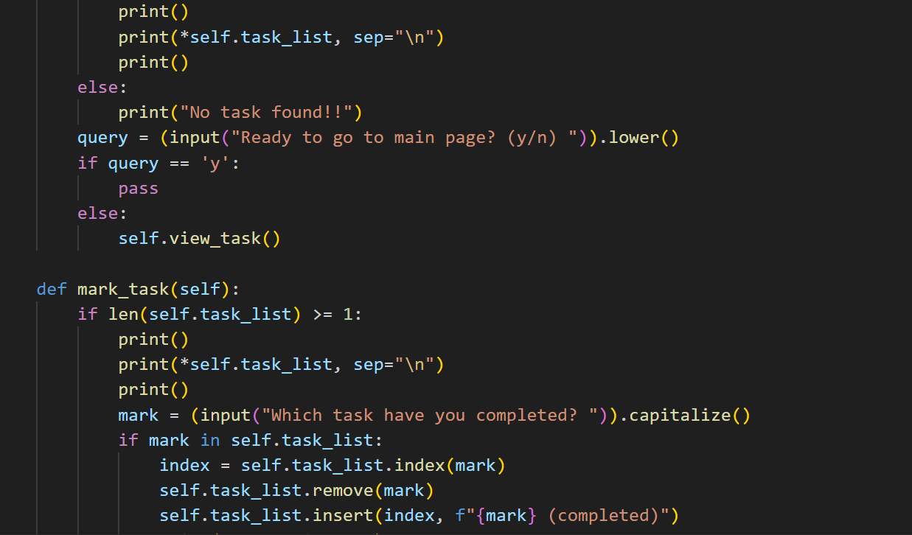

👀 3. view_task(self)
Purpose:
Displays all the tasks in the list.
Steps:
- Checks if there’s at least one task in task_list.
  - If yes, prints all tasks line by line.
  - If no, prints “No task found!!”.
- Asks user if they want to return to the main menu.
  - If no, re-displays the list.
  - 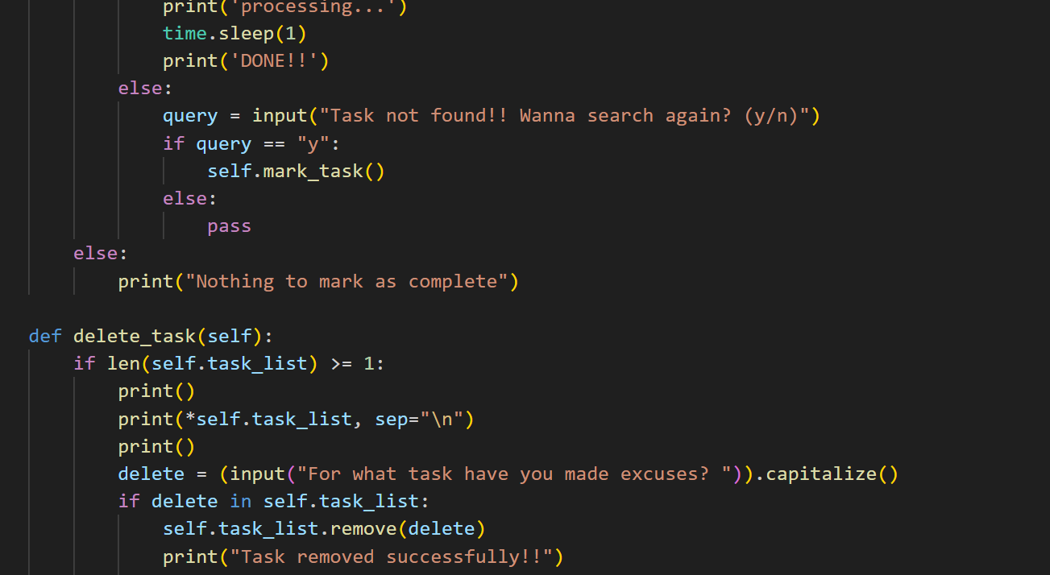

✅ 4. mark_task(self)
Purpose:
Marks a specific task as completed.
Steps:
- Displays all tasks.
- Asks which task was completed.
- If the entered task exists:
  - Finds its index and replaces it with “Task (completed)”.
  - Shows a “processing...” message for realism using time.sleep(1).
- If not found, asks user whether to search again.
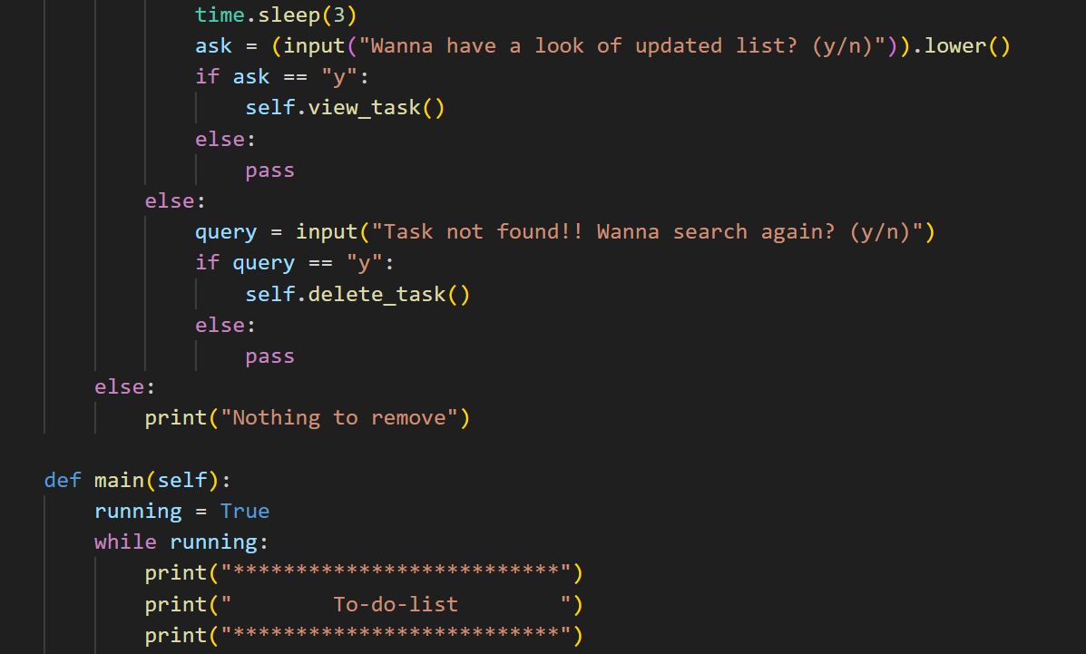

❌ 5. delete_task(self)
Purpose:
Removes a task that the user wants to delete.
Steps:
- Displays the current list.
- Asks which task to remove.
- If found, removes it from task_list.
  - Shows confirmation message and optionally displays updated list.
- If not found, offers to search again.
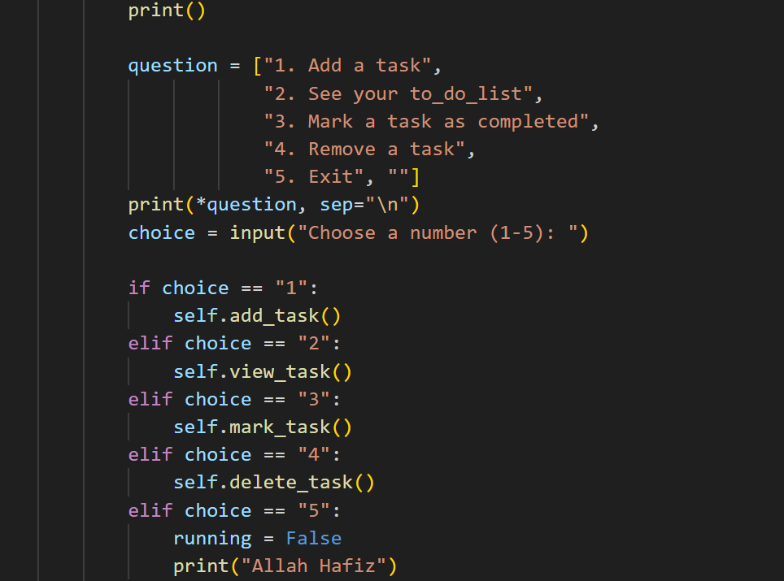

🏠 6. main(self)
Purpose:
Acts as the main menu / control center of the application.
Steps:
- Displays a text-based menu with options:
  - 1 → Add task
  - 2 → View tasks
  - 3 → Mark as completed
  - 4 → Delete task
  - 5 → Exit
- Takes user input (choice) and runs the corresponding method.
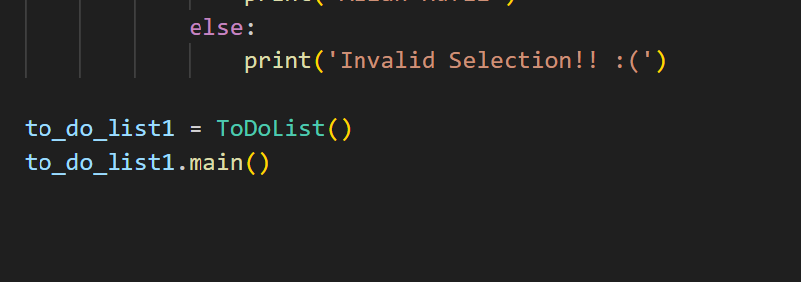

- If the user enters “5”, program exits with message “Allah Hafiz”.
- If input is invalid, shows “Invalid Selection!! :(”.

Program Flow Summary
- Object to_do_list1 is created from ToDoList.
- main() method runs automatically.
- The program stays in a loop until the user chooses to exit.
- All other functions are called from this main loop.

Features
✔ Add multiple tasks dynamically.
✔ Mark tasks as completed (without deleting them).
✔ Remove unwanted tasks.
✔ Repeated prompts for better user control.
✔ Recursion used smartly for re-trying input options.
✔ Simple and user-friendly command-line interface.

Limitations / Possible Improvements
- No file saving — list resets when program exits.
- Case-sensitive task names can cause mismatches.
- Could be enhanced using a graphical interface (Tkinter / PyQt).
- Could use persistent storage (like a .txt or .json file).

